Vendor Contract Look Up

Select Vendor Contract
From the AWARE Main Menu, select the “Vendor Contract” module
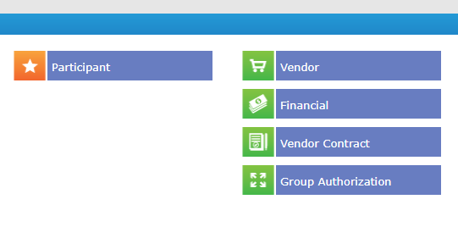

Vendor Contract Search
Ensure the elected layout is “Vendor Contract”. If it is not, navigate to the layout tab to choose this layout from the available options and select “Apply”.
Search for the Vendor by a combination of Name and/or Vendor Number. Search by navigating to the “Find” button.
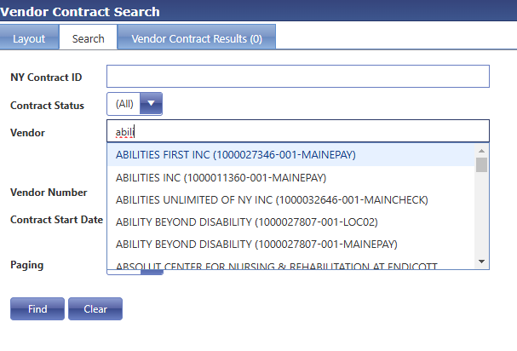

Select Current Contract Cycle
Navigate to the Results Tab. Review the results and select the ‘Contract Start Date’ and ‘Contract End Date’ that aligns with this CRS contract.
If there is no NY Contract ID for 24-28, the selected Vendor does not currently have a CRS award and you will choose “New Vendor” on the Review Form.

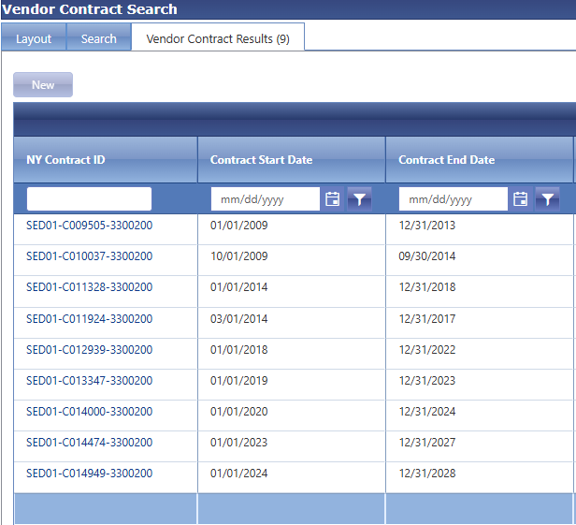

Search for Service Code
Review the ‘Vendor Contract Items’ for the specific Service Code you are reviewing. You can use the open text box under the Additional Information column to search by Service Code.
If the Service Code already exists as a Vendor Contract Item, you will choose “Yes” on the Review Form.

