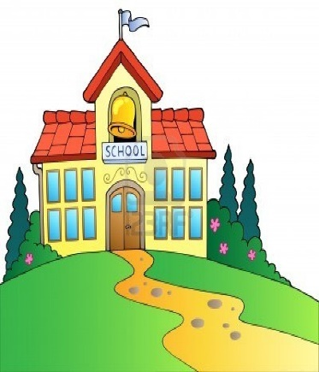

**Local Education Agency (LEA = school)**

**What is secondary transition?**

The Joint Agreement clarifies that OSE and ACCES-VR

* support the transition of students with disabilities from high school to post-school employment related activities and competitive integrated employment.
* provide informational training and resources for youth and families.
* ACCES-VR and OSE roles and responsibilities are clearly defined.

**What are the important parts of the OSE and ACCES-VR Joint Agreement for youth and families?**

ACCES-VR is responsible is responsible to support the transition planning as part of Pre-Employment Transition Services (Pre-ETS) for potentially eligible students who may need these services and other VR transition services for VR eligible students. Pre-ETS may include:

* Instruction in self-advocacy
* Counseling on enrollment in post-secondary education training programs
* Job Exploration Counseling
* Workplace readiness Training
* Work based Learning Experience

**Adult Career and Continuing Education Services – Vocational Rehabilitation (ACCES-VR)**

The Local Education Agency (LEA) is responsible to support the transition planning as part of the Individual Education Program (IEP) process that helps the student identify and achieve post-secondary goals through:

* Assessment and Planning
* Annual goal and post-secondary goal setting
* Coordinated classes, activities, and referral to community agencies.

Transition services must be addressed in the Individualized Education Program (IEP) of the student in the year in which the student turns 15 years of age and then annually each year after, or when requested by the student / family.

The IEP Team does not have to wait until the student’s approaching 15 birthday year to consider the student’s transition needs.

**When does this occur?**

**15**

**Years of age**

## For high school age students with disabilities:

* A bridge between a school program and the opportunities of adult life
* Involves partnerships between student, family, school, and the community.
  + - Builds on strengths, interests, and preferences; and addresses needs; and
    - Identifies services and supports needed to reach post-secondary goals of education / training, employment, and community engagement.

Office of Special Education ACCES (OSEA)

Joint Agreement